|  |
| --- |
| Synthesis and in situ characterization of graphene grown on liquid metal catalysts.  **Anastasios C. Manikas**1,2,#, **Christos Tsakonas**1, **Ilias Sfougkaris**2 and **Costas Galiotis**1,2*  1 Institute of Chemical Engineering Sciences, Foundation of Research and Technology-Hellas (FORTH/ICE-HT), Stadiou Street, Platani, 26504 Patras, Greece  2 Department of Chemical Engineering, University of Patras, 26504 Patras, Greece  # Presenting author: George Gorgolis, email: a.manikas@iceht.forth.gr  * Corresponding authors: Costas Galiotis, email: [c.galiotis@iceht.forth.gr](mailto:c.galiotis@iceht.forth.gr) |

abstract

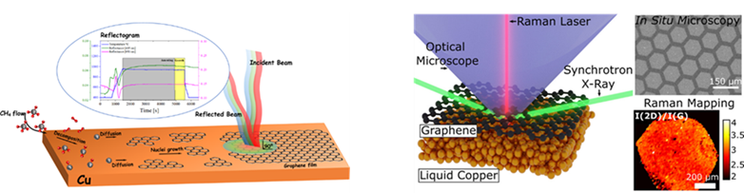Graphene formed by covalently linked carbon atoms, emerges as a promising contender for replacing existing materials in various applications. Chemical Vapor Deposition (CVD) stands out as the most recognized method for thin film synthesis, meeting the criteria for automated large-scale graphene production. Currently, most CVD approaches utilize solid metal catalysts (SMCat) for graphene growth, yet they often introduce structural imperfections like wrinkles, fissures, and grain boundaries. In contrast, employing Liquid Metal Catalysts (LMCat) for graphene growth could potentially yield defect-free single-domain graphene owing to the enhanced atomic mobility, uniformity, and fluidity of LMCat. The absence of in-situ techniques for direct observation of the growth process has hindered our grasp of process dynamics, leading primarily to empirical growth procedures. In this study, we unveil advancements in real-time monitoring of graphene growth, utilizing in-situ reflectometry for solid substrate graphene growth, and employing in-situ optical microscopy and Raman spectroscopy for graphene growth on liquid metal substrates. Furthermore, we delve into the superior properties of LMCat graphene concerning electrical and mechanical response. Lastly, we present current attempts to apply this methodology to other 2D materials such as hBN.

Figure: The different methodologies for in situ monitoring of graphene growth on solid and on liquid Cu.

**REFERENCES**

[1] Tsakonas, C., Manikas, A. C., Andersen, M., Dimitropoulos, M., Reuter, K., & Galiotis, C. (2021). In situ kinetic studies of CVD graphene growth by reflection spectroscopy. Chemical Engineering Journal, 421, 129434.

[2] Jankowski, M., Saedi, M., La Porta, F., Manikas, A. C., Tsakonas, C., Cingolani, J. S., Mie Andersen, Marc de Voogd, Gertjan J. C. van Baarle, Karsten Reuter, Costas Galiotis, Gilles Renaud, Oleg V. Konovalov, Groot, I. M. (2021). Real-time multiscale monitoring and tailoring of graphene growth on liquid copper. Acs Nano, 15(6), 9638-9648.